
520 N. Market Street
Frederick, MD 21701
(The old Head Start building)

520 N. Market Street
Frederick, Maryland 21701

A free afterschool clubhouse that is open to all youth in Frederick County, ages 12-17 years old.

Membership is Free!
Drop in and visit, and sign up for a free membership card.

Membership
Market Street Adolescent Activities Center/Clubhouse
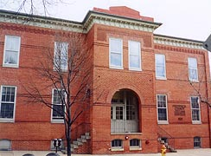

Located at:

Membership is FREE and open to all youth:

- Ages 12 to 17 years old
- Must be a resident of Frederick County
- Currently in treatment for substance abuse or…

- Struggling with substance abuse/ mental health issues or…

- Have successfully completed a substance abuse treatment program.



Contact:

Veronica Nimpson,
Program Director
Phone: 301-600-1126
Fax: 301-600-1135
vnimpson@frederickcountymd.gov

Cristen Cravath,
Care Coordinator
Phone: 301-600-1122
Fax: 301-600-1135
ccravath@frederickcountymd.gov



Be a part of the Market Street Adolescent Activities Center/Clubhouse!
Hours of Operation:
Monday – Friday: 3:30pm to 7pm
Saturdays: 11:00am to 5pm
Sundays and Holidays: Closed
The clubhouse is conveniently located on multiple public transit routes. Bus # 51 and 61 stops right before our building.

We are recruiting volunteers!
If you have a skill, talent, or expertise that you are willing to share or simply want to share your time with us, please contact Cristen Cravath at:
301-600-1122 ccravath@frederickcountymd.gov
A volunteer application form can also be found on our website!
http://www.frederickcountymd.gov/index.aspx?NID=5380

Activities:
The Clubhouse offers fun and sober activities:
- Homework tutoring and GED assistance
- Computer Lab
- Skills building and employment coaching
- Support group activities led by peer-recovery coaches
- Outdoor recreational activities, sports and field trips
- Indoor activities like pool, ping pong, air hockey, arts & crafts, dance, zumba, etc.
- Exercise, meditation, healthy cooking, snacks and family night
- Free afterschool snacks


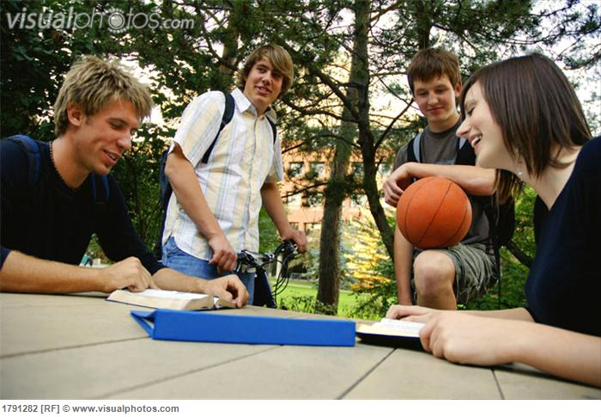

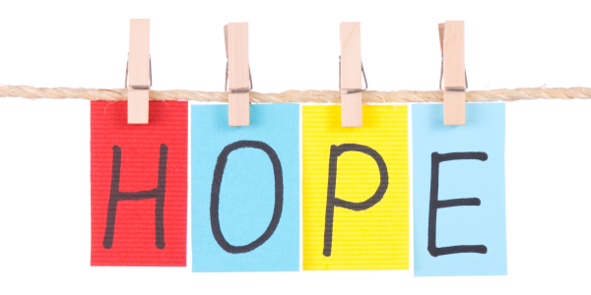

Mission:
The mission of the Activities Center is to provide a safe; community based adolescent clubhouse which provides developmentally appropriate services grounded in a peer-based support system. The model will incorporate core values such as:

- Family focused with inclusive definition of family
- Self-directed recovery
- Focus on total wellness
- Empowerment
- Strengths based, realizing multiple capacities, resiliencies, talents and coping abilities
- Peer support
- Promoting pro social development
- Social and community relationships
- Respect and responsibility
- Hope

